1. Home Page -> Visit <http://localhost:8081/>

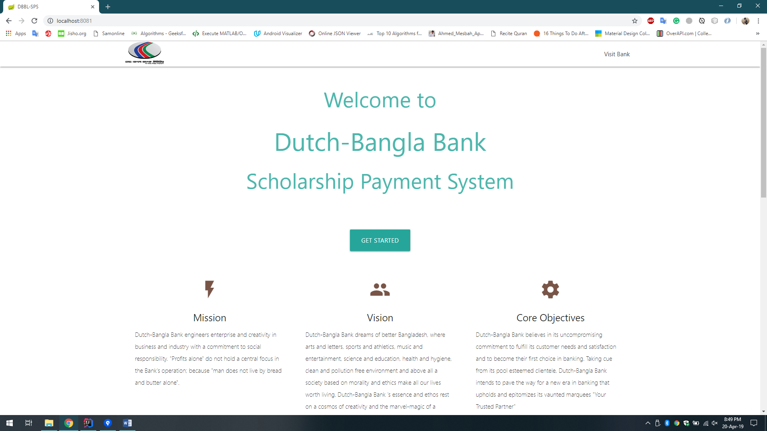

1. “Visit Bank” takes you to the Bank’s website.
2. Login -> Click “GET STARTED” to login.

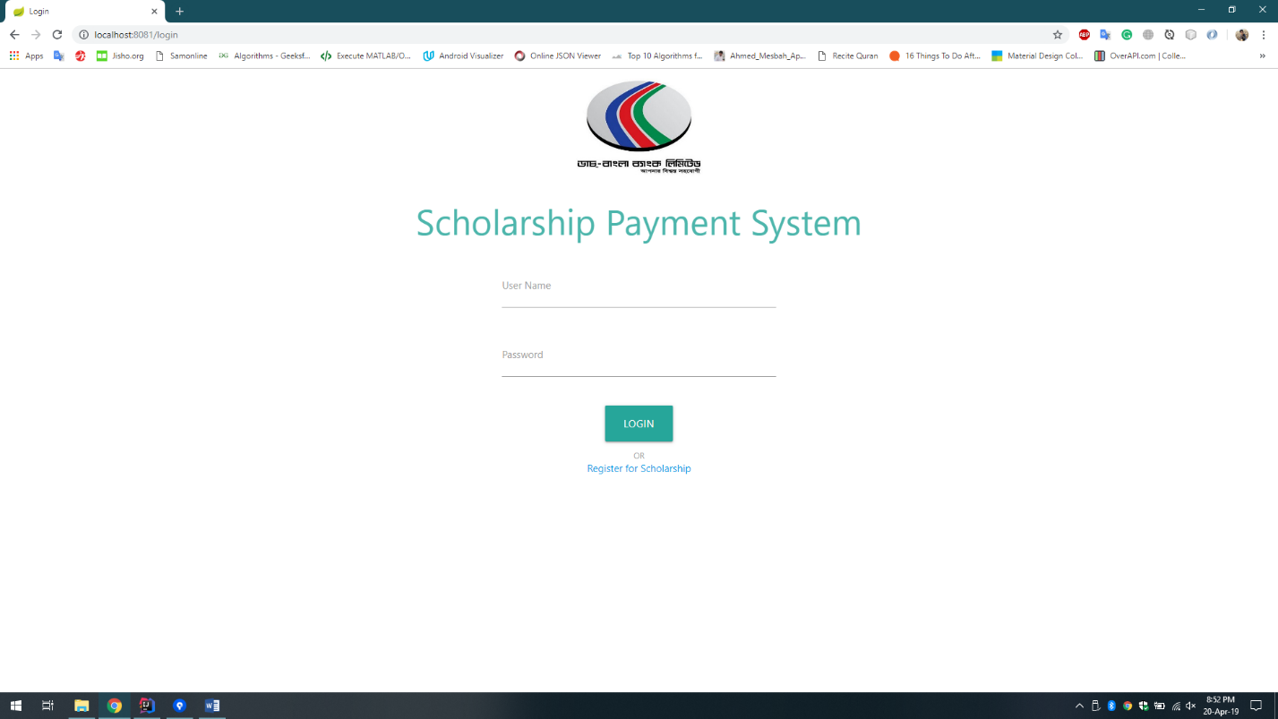

1. “Register for Scholarship” takes you to the registration page.

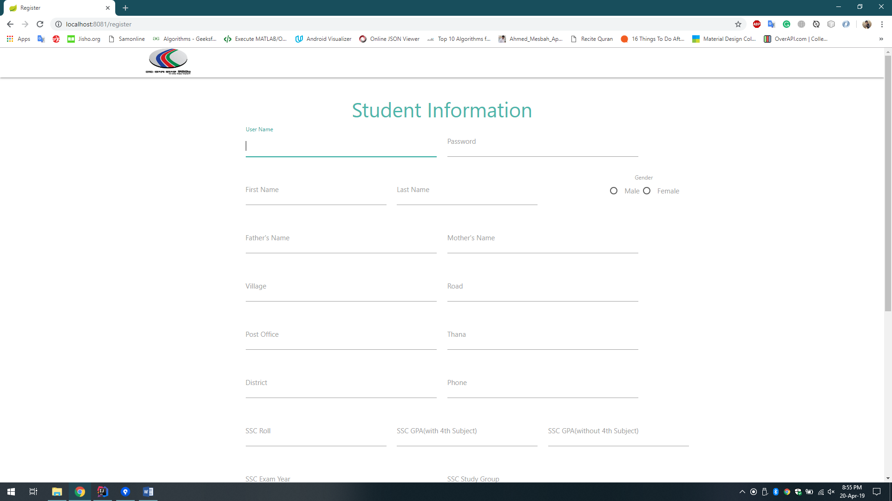

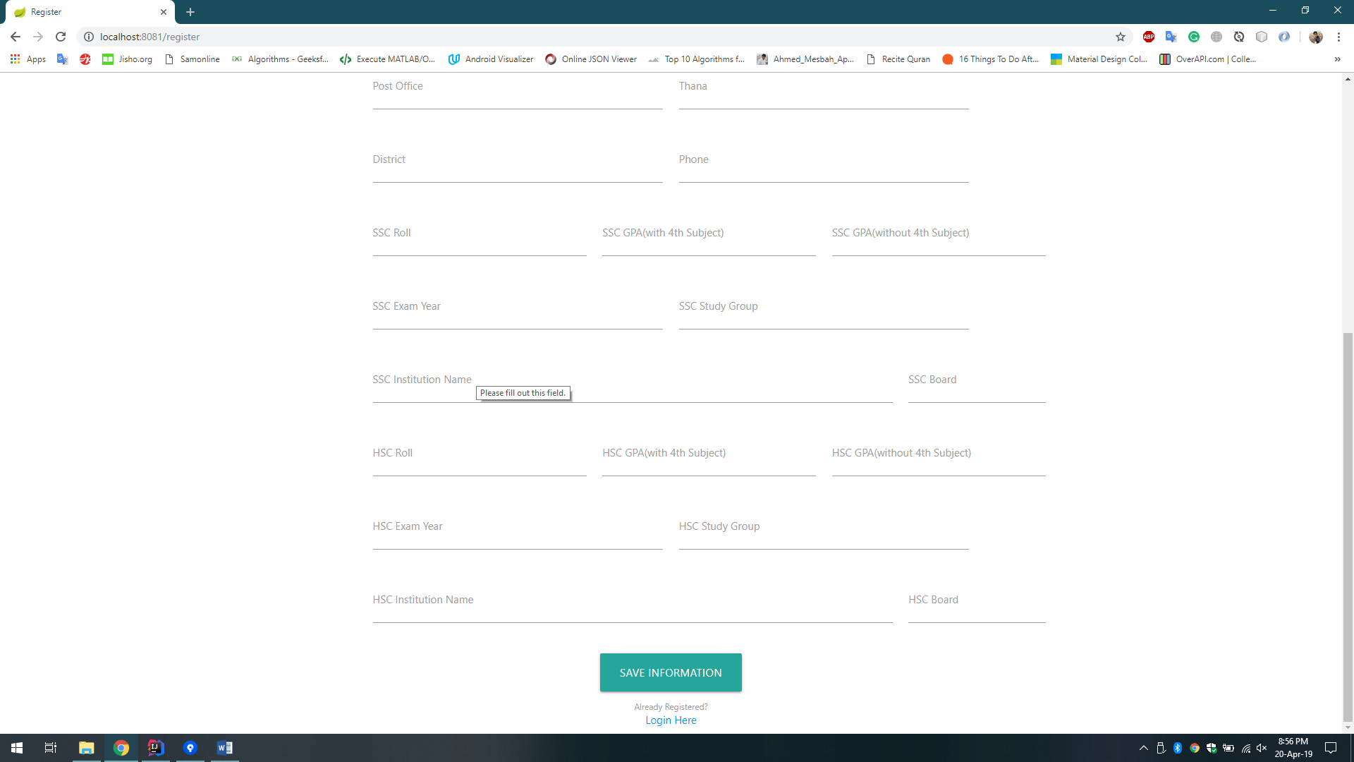

1. After successful registration end user will see this page.

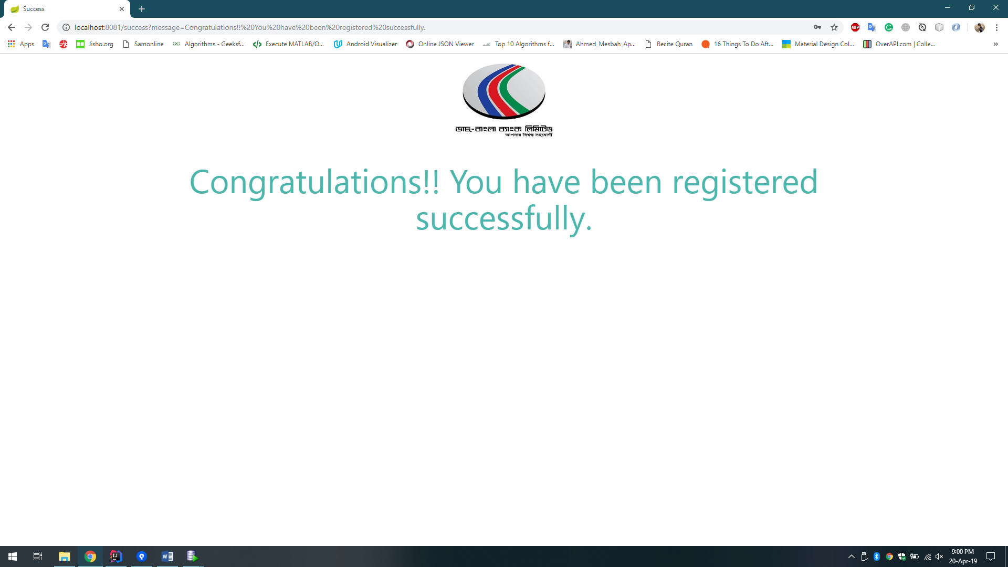

1. End users can update their information again after logging in until the result is published.

Here is the update page:

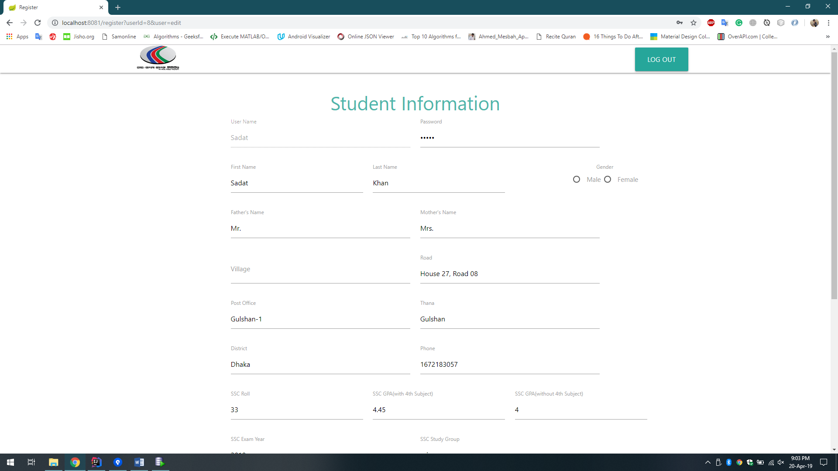

1. Admin user will see all the students after logging in.

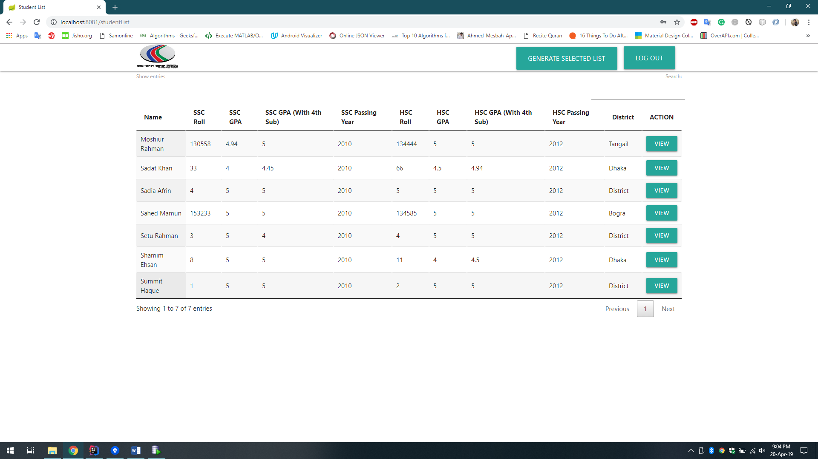

1. By clicking the “View” admin will be able to see the details information in read only mode meaning that he cannot update any information.

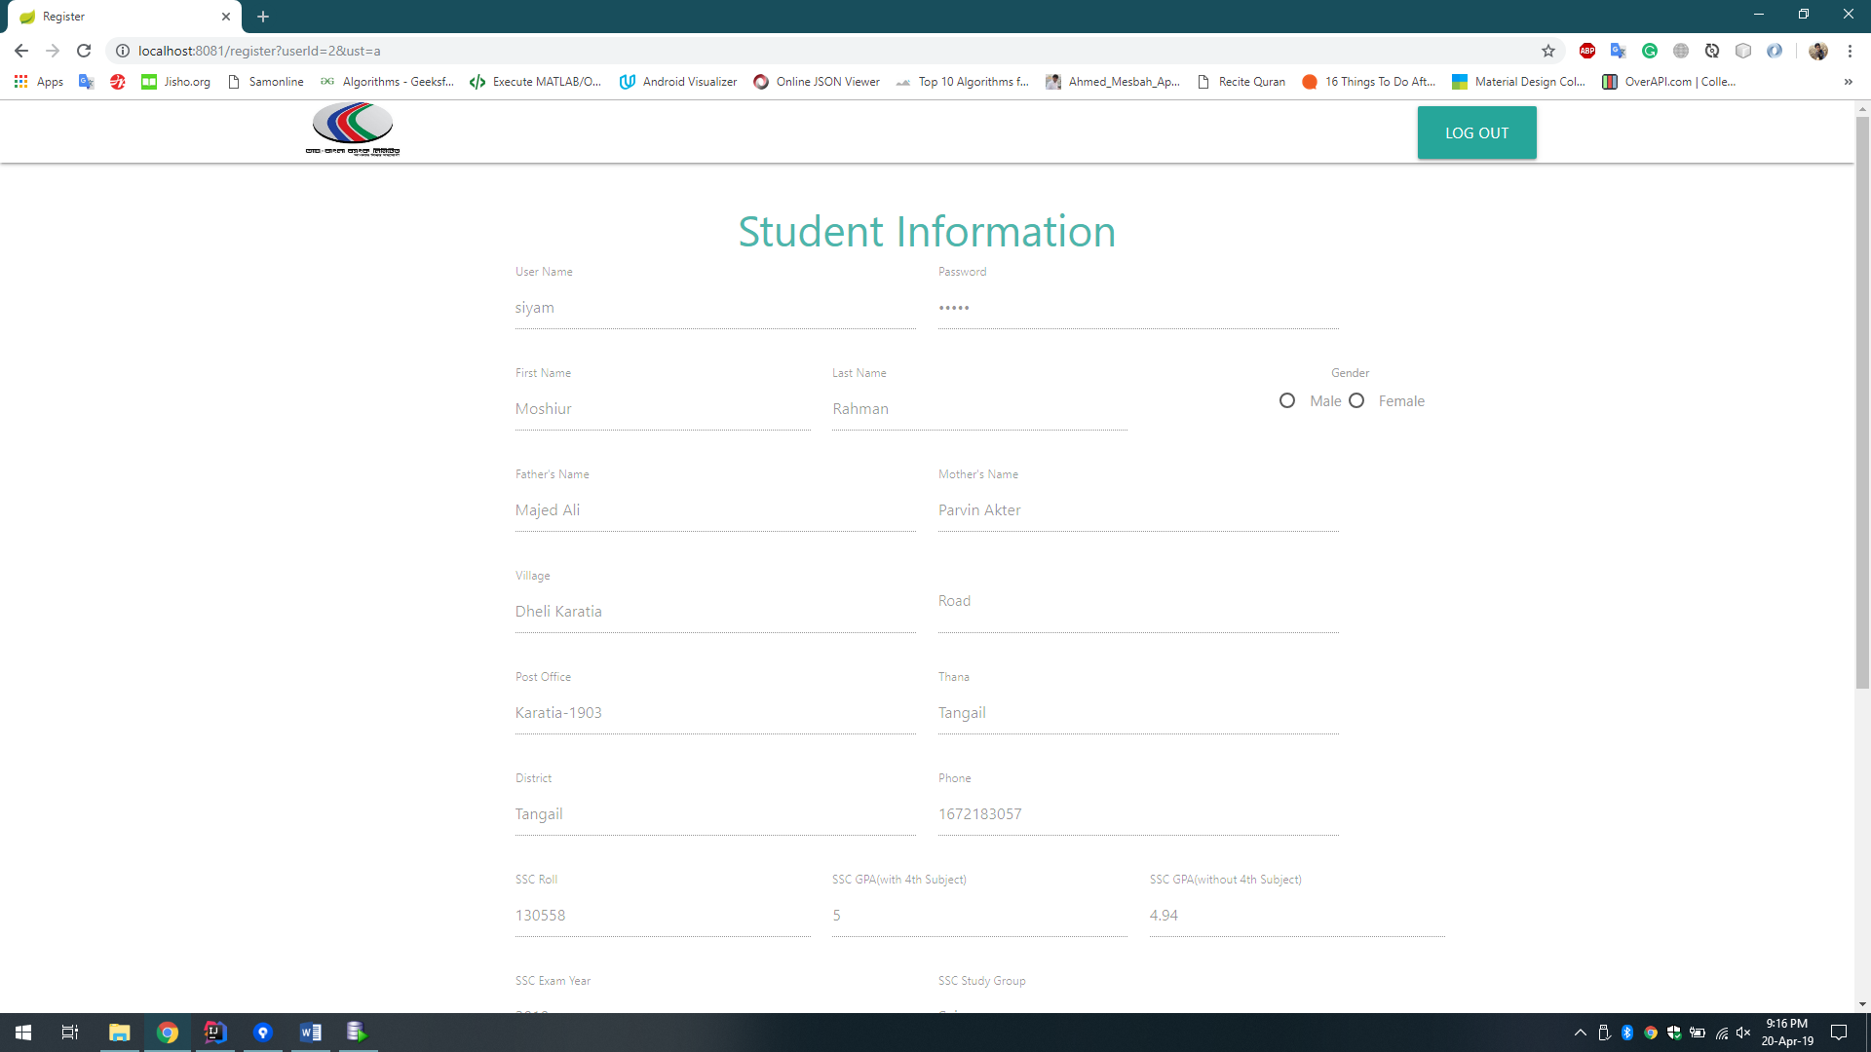

1. “Log Out” button redirects every user to the home page.
2. By clicking the “Generate Student List” admin can generate the selected students for scholarship.

Scholarship criteria: 1) Higher GPA.

2) 50% male and 50% female.

3) Maximum number of selected student is: 50% of total student + 1.

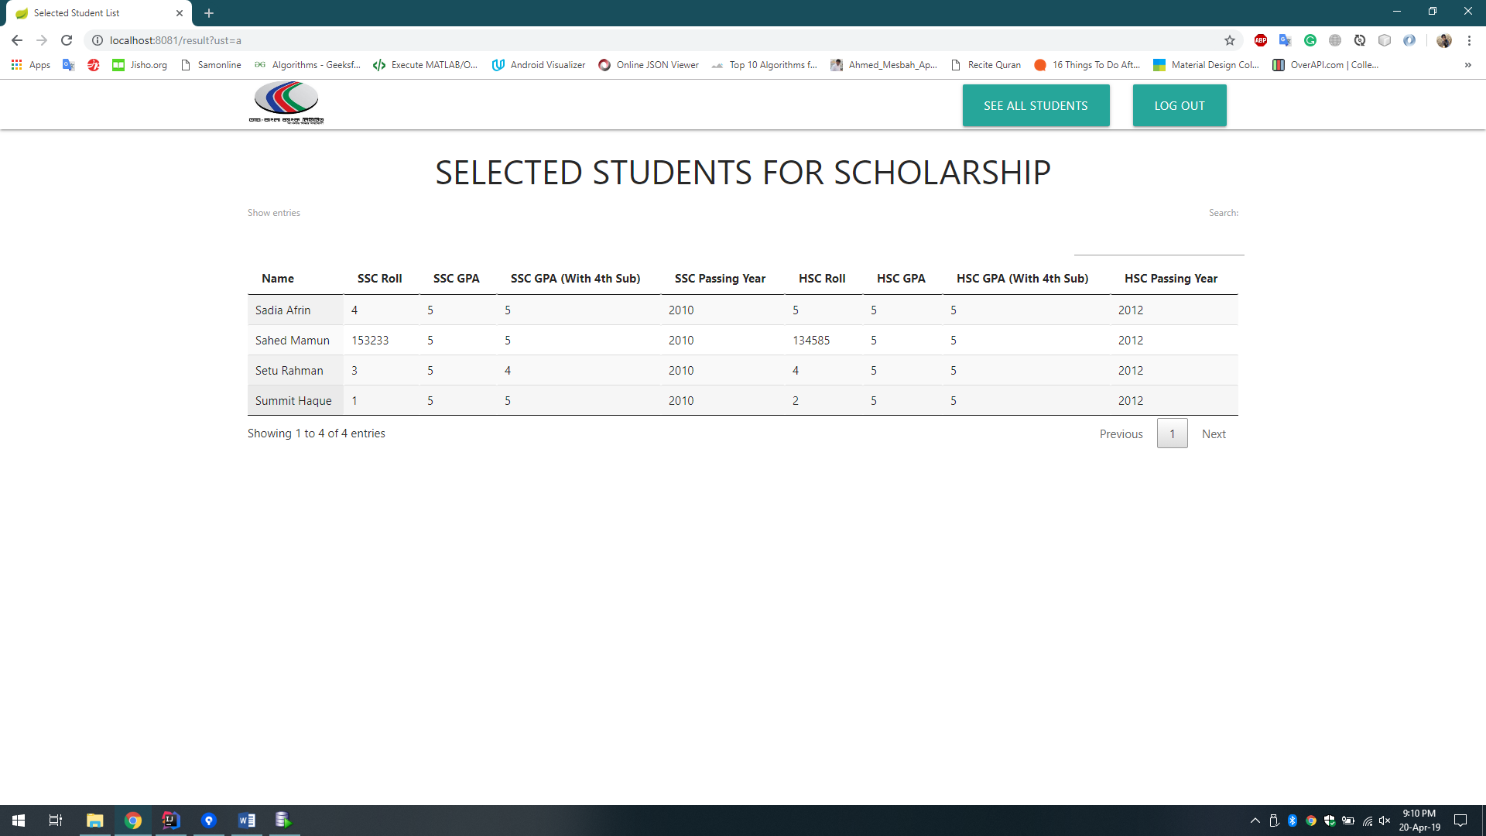

1. Once the result is generated, end user cannot update his/her information anymore and will be redirected to the selected student list after login.